**1.Running the program:**



**2.Entering the MySQL credentials:**

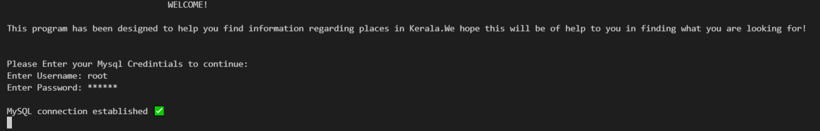

**3.The Main menu appears:**

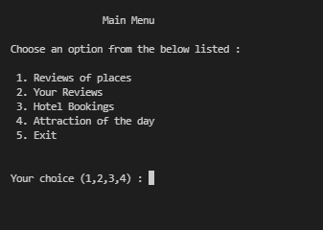

**4.Selecting choice- 1** (ps: The red underlined are the inputs) :

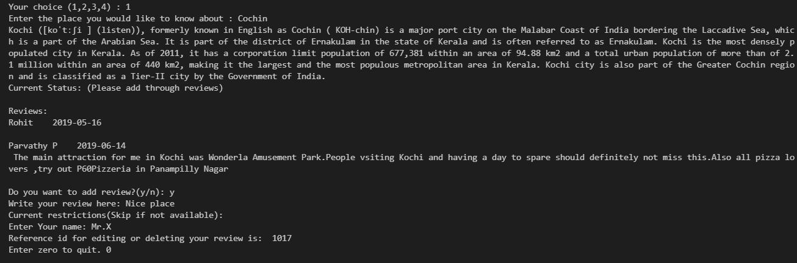

**5.Selecting choice 2**

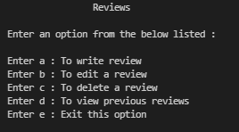

**5.1 Choosing a:**

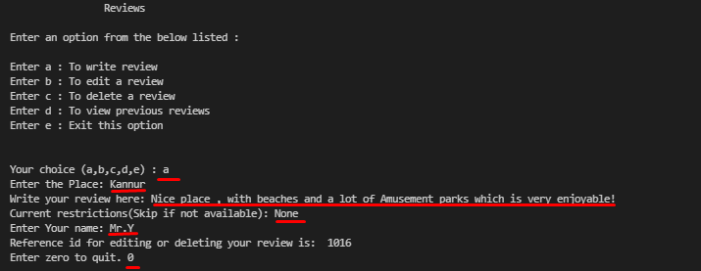

**5.2 Choosing b:**

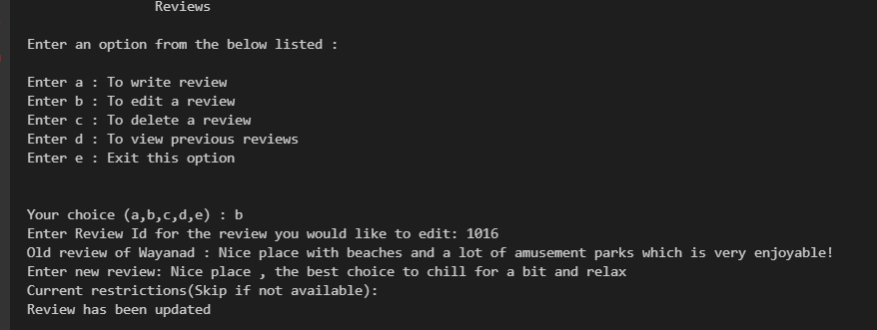

**5.3 Choosing c:**

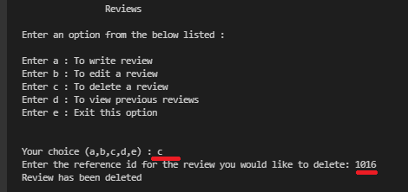

**5.4 Choosing d :**

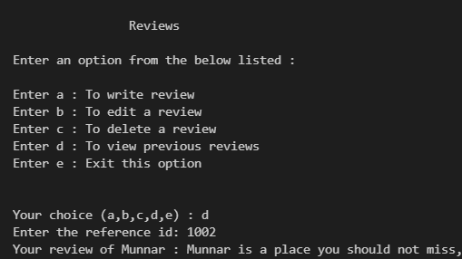

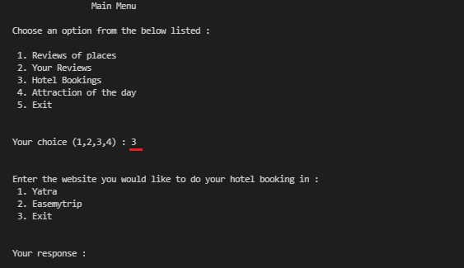**6.Visiting the Hotel Booking Module**

**6.1 Choosing Yatra:**

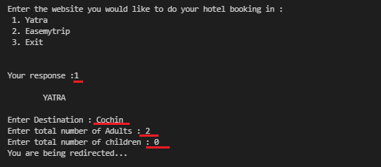

This then redirects you to the yatra website through yours default browser and a new window opens up, an example of the same is given below.

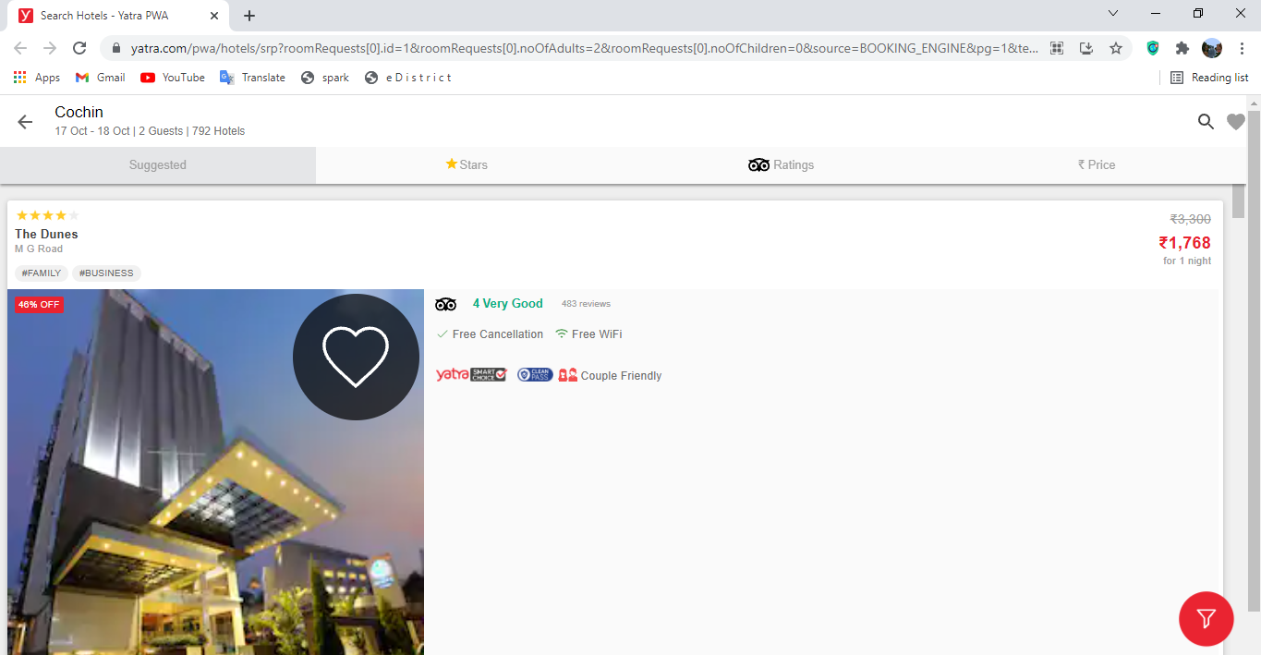

**6.2 Choosing EaseMyTrip:**

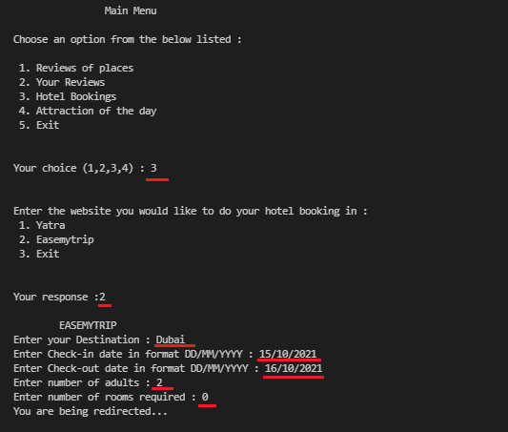

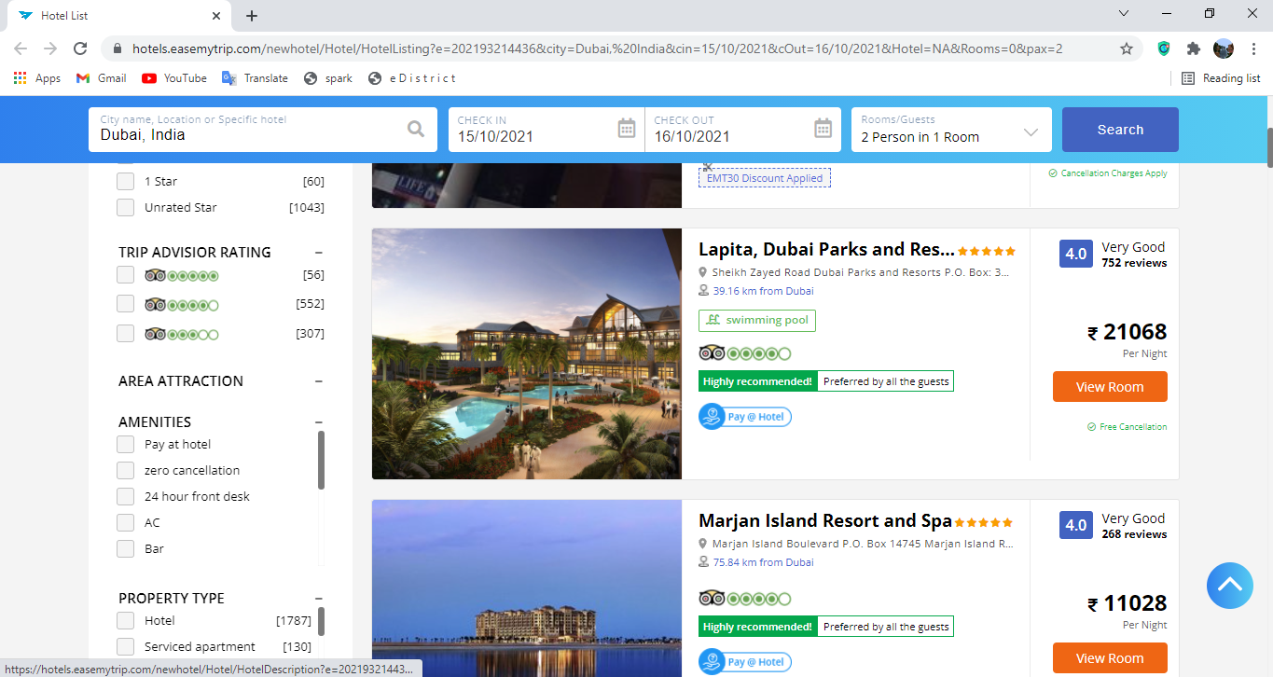It redirects you to an external website easemytrip.com through your default browser.

**7.Checking out the attraction of the day ! :**

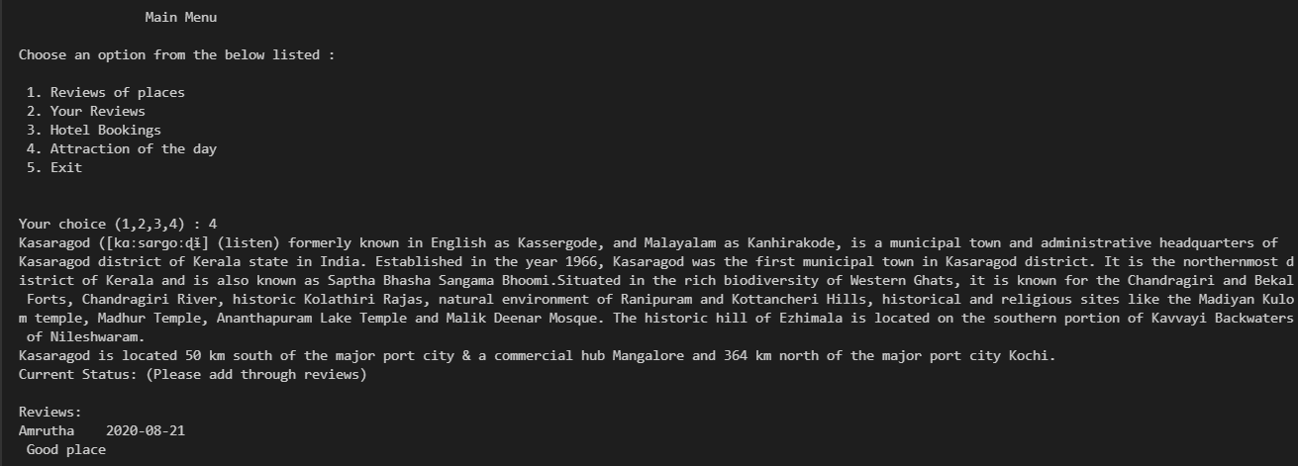

**8.Exiting from the program:**

